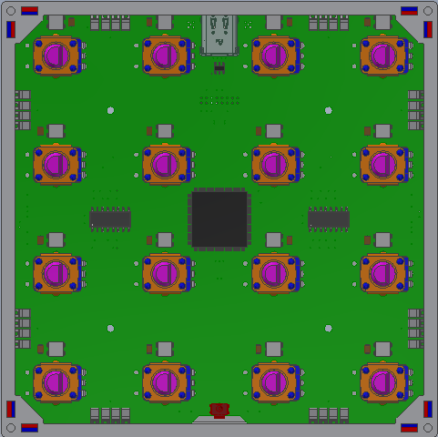
Grid4 Specification

Table of Contents
Specification Summery 3
Grid Features 3
Mechanical design 4
Form factor 4
Plastic housing 4
Aluminum front panel 4
PCB 4
Top level overview 5
Interface design 6
Magnets 6
Pogo pins 7
Interface Board (Sub-assembly) [HW Component] 8
Pogo Pin (External) [HW Component] 9
Pogo Pin (Internal) [HW Component] 9
Grid Protocol [FW Component] 10
Grid4 USB Composite Device (FW Component) 11
Source: G4 Project 11
When connected to a USB Host, a Grid4 module shows up as a USB Composite device by default. If the Mapmode button is pressed during the startup, the module enters bootloader mode and enumerates as a USB Mass Storage Device. The binary firmware file can be directly copied to the device. 11
Grid4 USB Translator (FW Component) 12
Source: G4 Project 12
The Grid Translator takes the Grid4 Protocol communication and converts the messages the fit the supported USB Classes and vice versa. 12
12
CDC Serial (Raw Grid4 Protocol) 12
Audio Device - Midistreaming (Translated) 12
Grid4 Configurator (SW Component) 13

Specification Summery

Grid Features
- Ultra-mobile MIDI controller solution
- Extendable control surface (Grid magnetic interface)
- USB C receptacle
- USB Bus powered device (5V 3A, optional PD)
- USB2.0 compliant composite device (Audio Device Midi, CDC Serial, DFU Bootloader)
- Compatible with Windows, Mac and Linux (No drivers needed)

- Tactile user interface
- Aluminum front-panel
- Full-color RGB LEDs
- Compact size: 106mm x 106mm x 16mm (4.2” x 4.2” x 0.6”)
- Light weight: 200g (7oz)
- Eurorack compatible (21HP)

Mechanical design

Form factor
The nominal module dimensions are 106.6mm*106.6mm*16mm.
106.68mm = 21HP = 4.2in

Plastic housing
The injection molded plastic housing is 106.6mm*106.6mm*14.4mm.
Outer draft angle: 0°
Inner draft angle: 2.5° nominal
Material: ABS or PP
Color: White

PCB
The main printed circuit-board is 100mm*100mm*1.6mm.
Material: FR4 (TG130-140)
Layer count: 4-layer
Stackup: TBA
Surface: Immersion Gold.
RoHS

Interface design
The for sides of the controllers have identical interfaces for communication. These are referred to as North, East, South and West going clockwise around the controller.

Magnets
The modules are held together by the magnets. This provides the mechanical stability of the control surface. Two neodymium magnets are installed on each side of the controller.
Each magnet has a North and South pole (not to be confused with the sides of the controller.) North pole is usually Red, the South pole is usually (Blue or Green)
Illustration 1: B-12-4-2N38 from MagnetPlanet
Illustration 3: Interaction of two permanent magnets (Wiki commons)
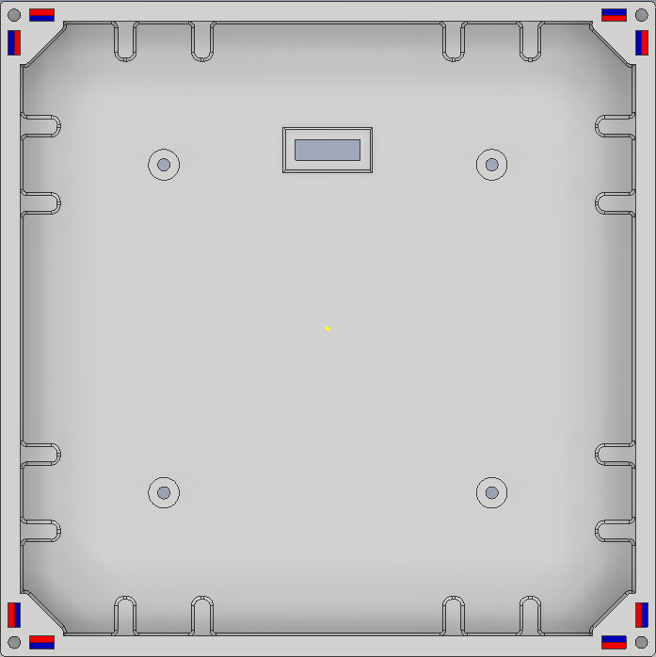Illustration 2: Top view of the plastic housing with the magnets installed.
NORTH

WEST EAST

SOUTH

Pogo pins
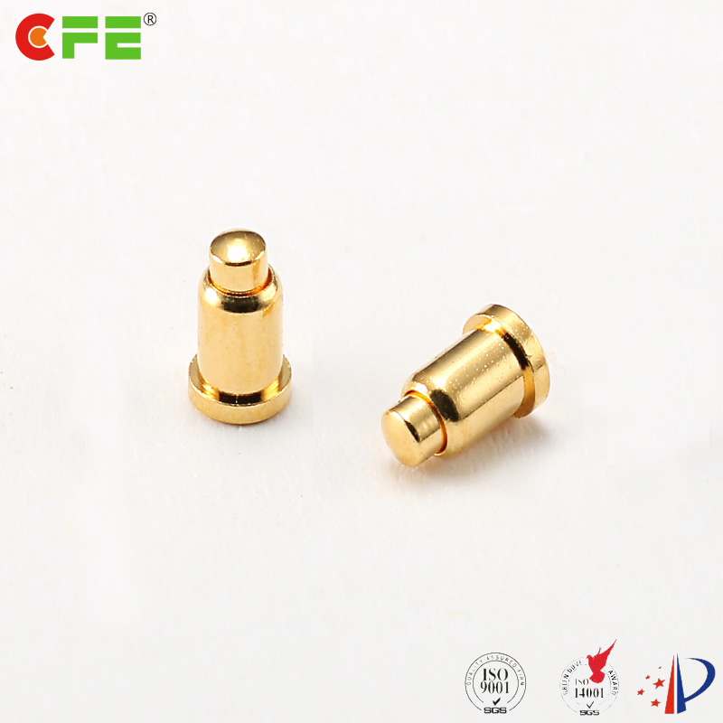Illustration 4: Male pogo pin connector
Spring loaded pogo pin connector are used to electrically interface two neighboring module. These connectors provide bidirectional data and power throughout the Grid. Each side of the module has eight pins. All of the pins are spring loaded (male type). Working height has to be as short as possible to reduce the overall stress on the pin during mating.
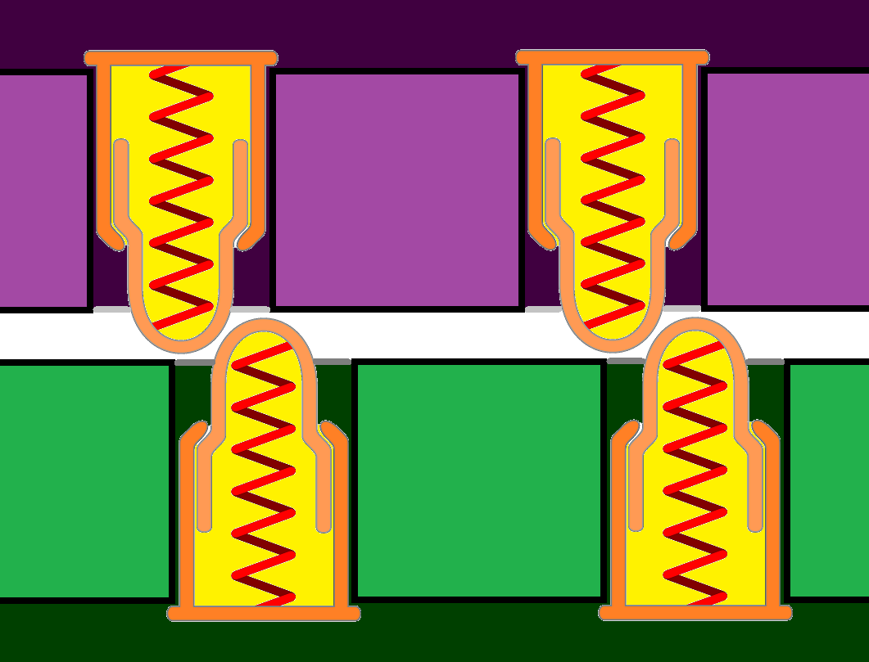Illustration 5: Worst case stress on the pogo pins

Physical composition
Each component in the Grid ecosystem is carefully designed to be reusable in the upcoming designs.
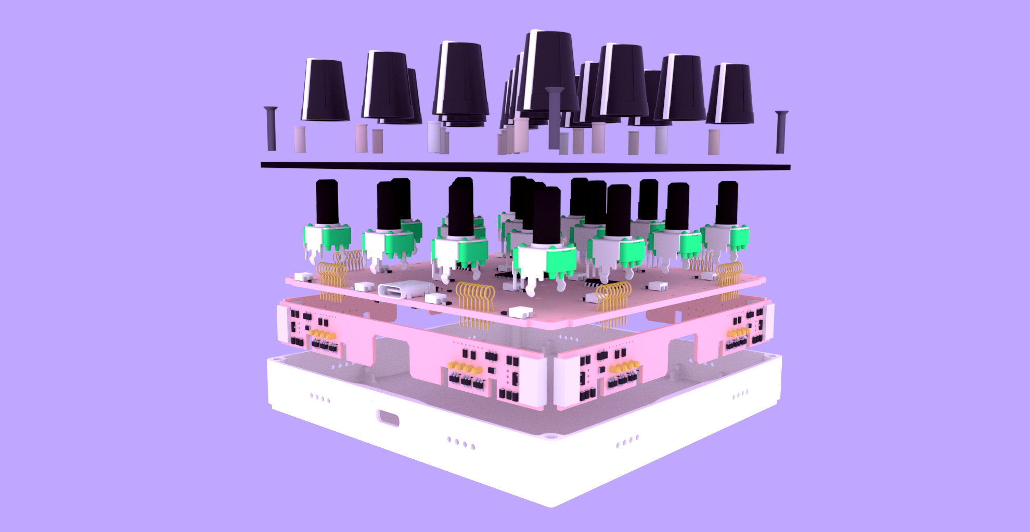
1
2
3
4
5
1. Injection molded plastic housing
2. Aluminum front-panel
3. Main PCB accommodating the user interface and the main application processor
4. Interface PCB designed to connect to the neighboring modules
5. Potentiometer caps and other tactile components

Main PCB
There are a number of components on the main PCB that are common across all Grid modules. This allows the reuse of the housing and most of the firmware components.
2
1
3
4
5
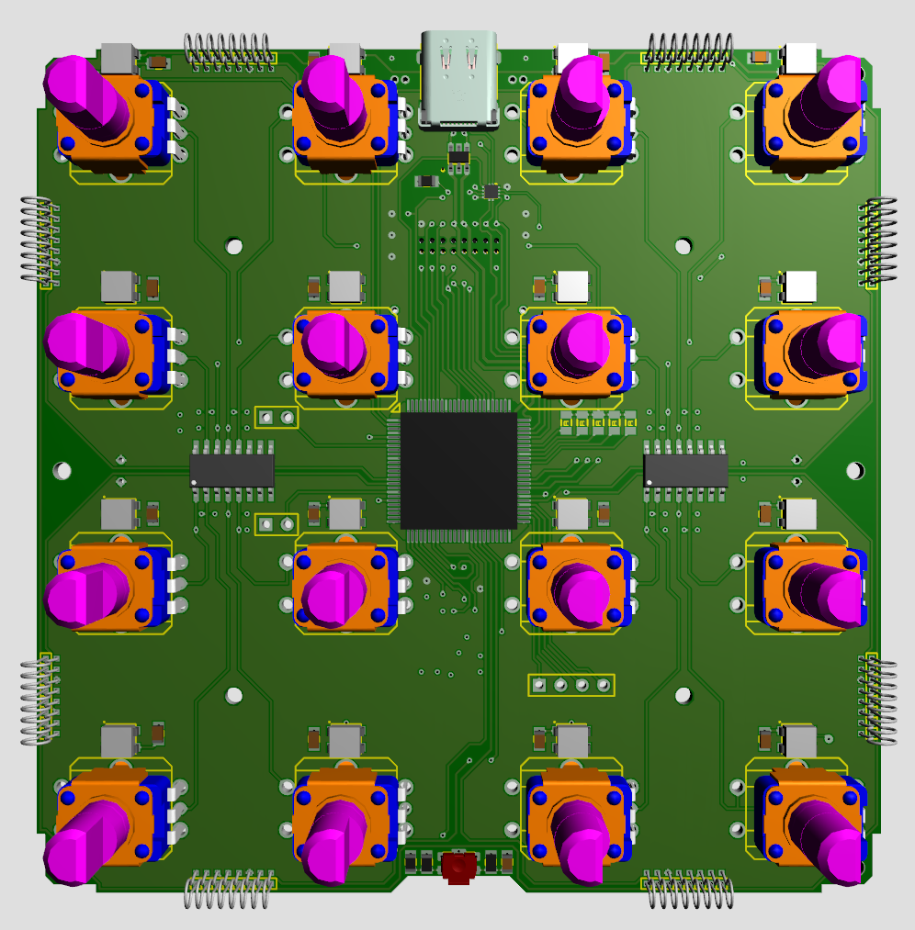Figure 1: Main PCB of the P16 module
1. Main application processor
2. USB C connector and support circuitry
3. RGB LEDs
4. Bottom entry docking connector (eurorack)
5. Map mode button

Interface Board (Sub-assembly) [HW Component]
Source: G4 Project → G4 Elec / Design
Every module has four interface boards designed to accommodate the signal switching, ESD protections and field detection circuitry. The installed pogo pins make contact with the neighboring modules, while the elongated pads on the other side mate with the spring loaded thest points on the modules main PCB.
Nominal parameters of the board:
- 12mm * 96mm dimensions
Requirements for the interface board:
- The finished FR4 PCB must be 1mm thick
- It must fit one 10mm * 6mm * 3mm neodymium magnet on each side
- The SMD components must be on one side of the board (facing away from the module)
- The SMD components must not be higher than 1mm (always check boundary box)
- For production the board must be Lead-Free (RoHS)
- For production the pads must be gold plated (immersion gold)

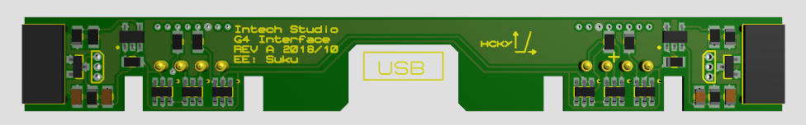
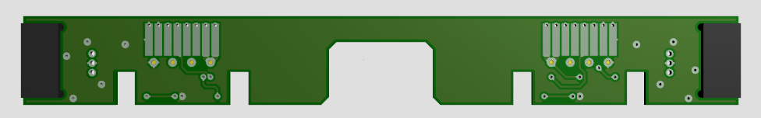

Pogo Pin (External) [HW Component]
Source: Grid / Mechanical / Design / Pogo
The Spring loaded connectors that are used on all four sides of the controllers are custom designed by Intech Studio. Design files and requirements can be found in the Mechanical submodule of the Grid4 repository.
Each interface board has 8 pogo pins, a total of 24 pins are required for each Grid4 module. The pins are THT (Through-Hole), but they are only 1mm long so they are flush with the solder side of the Interface board. They can be hand soldered or reflowed (pin-in-paste).
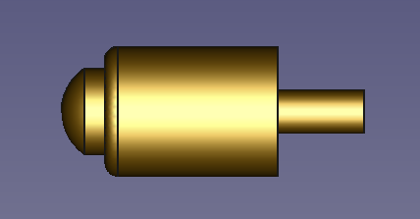Figure 2: CFE: Custom manufactured component.

Pogo Pin (Internal) [HW Component]
Source: Grid / Mechanical / Design / Pogo
Pogo pins are used to connect the interface boards to the main PCB. This allows quick, non-destructive replacement of the interface board (ideal for testing and servicing). Designed for SMD reflow soldering. For production this pins can be replaced with solder fillets to save cost.
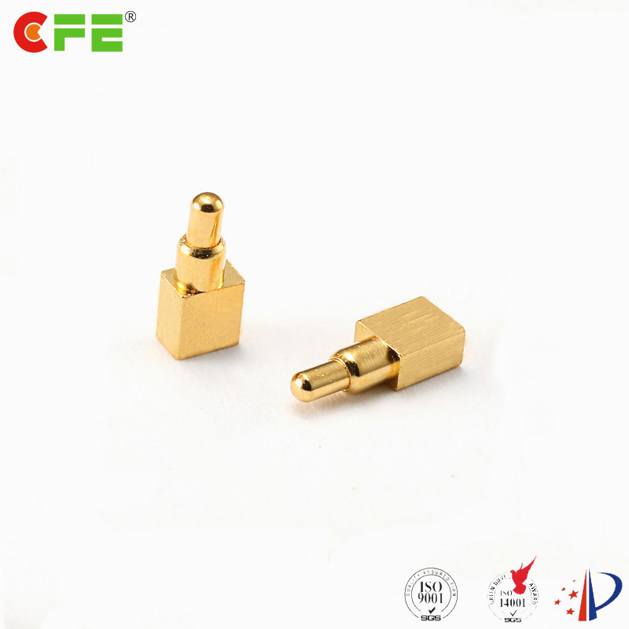
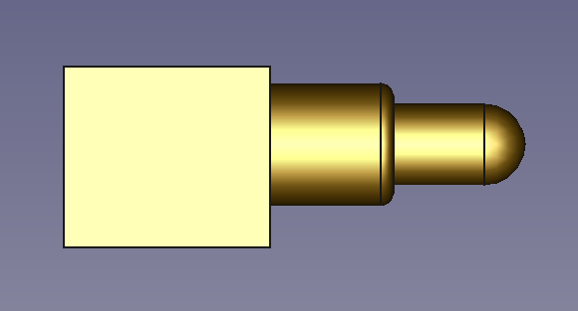Figure 3: CFC: BP109621

Grid Protocol [FW Component]
Source: G4 Project
Grid4 Modules use the Grid protocol to communicate through the magnetic interface. The Grid protocol is optimized for high data throughput, efficient error detection and low latency. The data has to be formatted by the host module (the one connected to the USB port) to match the format of various USB Classes, most importantly the USB Hid MIDI Specification. All addresses and commands have to be mapped to a supported Midi parameter. The Grid4 USB Translation strategy can be configured by the user from the Grid4 Configurator.

Grid4 USB Composite Device (FW Component)

Source: G4 Project

When connected to a USB Host, a Grid4 module shows up as a USB Composite device by default. If the Mapmode button is pressed during the startup, the module enters bootloader mode and enumerates as a USB Mass Storage Device. The binary firmware file can be directly copied to the device.

Grid4 USB Translator (FW Component)

Source: G4 Project

The Grid Translator takes the Grid4 Protocol communication and converts the messages the fit the supported USB Classes and vice versa.

Grid 4 Protocol
USB Stack
CDC Serial
(Grid4 Protocol)
HID Midi
(Translated)
HID Keyboard
(Translated)

CDC Serial (Raw Grid4 Protocol)
The Grid4 Protocol is directly sent over USB through the CDC Serial driver. This allows the most flexible software integration, can be used by a custom Driver Utility to control non MIDI applications like Adobe Photoshop, Premier Pro and More.

Audio Device - Midistreaming (Translated)
The Midi driver can by used by any Midi compatible application. This does not require additional drivers. The challenge is to map the Grid4 Protocol’s addressing scheme to fit the USB Midistreaming specification.

Grid4 Configurator (SW Component)
Source: G4 Project
Addressing
- Fixed address (Saved on module)
  - Set CC number per controller
- Relative address (Based on position)
  - CC number is also relative
Input modes
- Button
  - Note On / Not Off (momentary)
  - Note On / Not Off (toggle)
  - Note On / Not Off (stepping increment range)
  - Control Change (on / off = high / low value)
  - Control Change (stepping increment range)
- Potentiometer
  - Control Change (0-127)
  - Control Change (Center dent calibration)
  - Note On / Not Off (Voltage comperator)
- Encoder
  - Button: Note On / Not Off (momentary)
  - Button: Note On / Not Off (toggle)
  - Note On / Not Off (stepping increment range)
  - Rotation: Control Change (Relative/Incremental)
- Analog input
  - CV input: Control Change (Sample rate limiter, resolution limiter, smart noise AI)
  - Gate input: Note On / Note Off (Logic -level comperator)
  - Audio input: Soundcard Driver (Sample rate, Bit depth)

Output modes
- LED
  - Actuator (R, G, B, A)
  - Static A (R, G, B, A)
  - Static B (R, G, B, A)
  - Pulse (R, G, B, A)
- Analog output
  - CV Output: TBA Midi Mode
  - GATE Output: TBA Midi Mode

